**Nouland M. RealdaJr.**

**Address: Blk 287 Lot 15 Zone 11 Pabo Real St. Brgy. Rizal Makati City**

**Email add: landrealda17@gmail.com**

**Mobile No. : 09978154179**

**------------------------------------------------------------------------------------------------------------------------------**

|  |
| --- |
| **OBJECTIVES:** |

**To be employed in a worthy endeavor where I can contribute the best of my abilities to achievement of goals in being good service.**

|  |
| --- |
| **PERSONAL DATA:** |

**Age : 27yrs old**

**Date of birth : November 17, 1995**

**Place of birth : Isabela**

**Religion : Roman Catholic**

**Height : 5’5 ft.**

**Weight : 69 kg.**

**Sex : Male**

**Civil Status : Single**

**Citizenship : Filipino**

**Father’s Name : Nouland R. Realda**

**Occupation : Aircon Technician**

**Mother’s Name : Jannette M. Realda**

**Occupation : None**

**Language Spoken : Tagalog,English**

|  |
| --- |
| **SKILLS:** |

* **Computer Literate ( I’m proficient basic knowledge in Microsoft Word, Excel and Power point)**
* **Flexible, Hardworking and responsible**
* **Ability to work in a team environment**
* **Computer Network Configuration and Computer Hardware**
* **Web Design, Wordpress, AEM Adobe Experience Management**
* **Corel Draw And Adobe Photoshop Adobe Illustrator. SKETCHUP**

|  |
| --- |
| TRAINING CERTIFICATE: |

**SAP June 2016**

**CCNA June 2016**

**Adobe Experience Manager Feb 2022**

|  |
| --- |
| **WORK EXPERINCE:** |

**Position: Graphic Artist**

**Company: SURAJ International Corporation**

**Year Experience: 2017-2019 / 1year and 2months**

**Position: Graphic Artist**

**Company: SOEN Garments Corporation**

**Year Experience: 2020-2021/ 11Months**

**Position: HTML Application Developer Position**

**Company: ETEM Inc. *Agency* (ACCENTURE)**

**Year Experience: 2021-2022/ 1year and 1month**

**Position: Junior Graphic Artist**

**Company: LICA LAND (OFFICEBUSTERS)**

**Year Experience: 2022-2023/ 8Months**

**Position: Web Graphic Designer**

**Company: Silver Goose 8 International Inc.**

**Year Experience: 2023 - Present**

|  |
| --- |
| **EDUCATIONAL BACKGROUND :** |

**Tertiary : International Electronics And Technical Institute**

**(Bachelor of Science And Information Technology)**

**Graduate 2019 - 2021**

**Address : 5 T. Molina, Alabang, Muntinlupa, 1770 Metro Manila**

**Secondary : International Electronics And Technical Institute**

**(Information And Communication Technologies)**

**Graduate 2014 - 2016**

**Address : 4th floor Guadalupe Commercial Complex, Makati**

**Primary : Fort Bonifacio High School**

**Graduate 2009 - 2013**

**Address : Dr Jose P. Rizal Ext, Makati, 1630 Metro Manila**

|  |
| --- |
| **CHARACTER REFERENCE:** |

**Russel Austria : IT On Site Support**

**: Brgy. Rizal Makati City**

**: 09196963381**

**David P. Veron : Software Analysis**

**: Alabang, Muntinlupa**

**: 09465555576**

**Eurie Alberastine : App/Cloud Support Specialist**

**: Cebu City**

**: 09992244903**

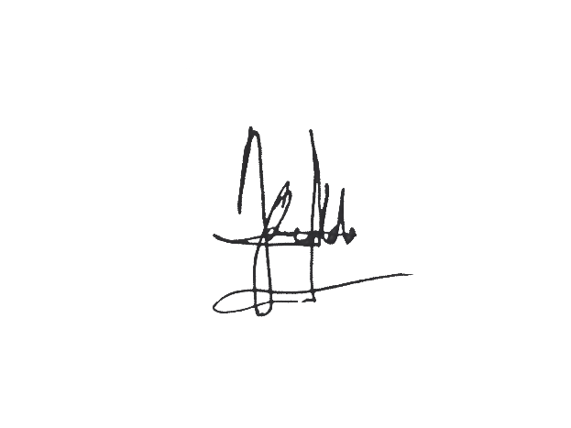

**__________________**

**Applicant’s Signature**